**Exercises Group data**

**Exercise 1**

In this exercise you use the file *classrooms.txt*. In this file you will find for each student his surname, first name and the classroom where he will attend. The records in the file are grouped by room and by surname.

Write a program that prints an overview to see which students are in each classroom.

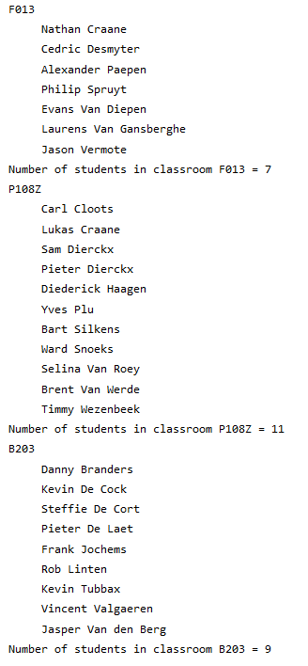

**Exercise 2**

In this exercise you use the file *courses.csv*. In this file you will find a number of records for each student: one for each course the student records. Per record you will find

* z-code
* course name
* student group
* student number
* surname
* first name

Write a program that creates a new file *students.csv* in which you have only 1 record per student.

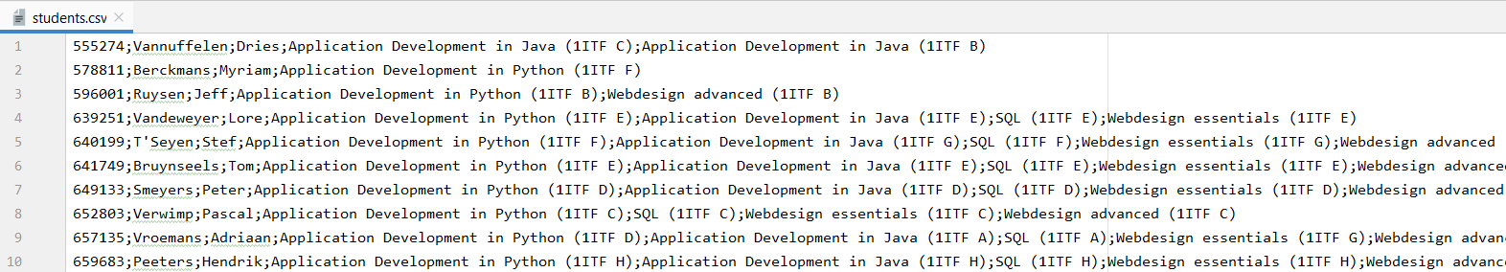

**Exercise 3**

In this exercise you use the file *weatherstation_2018 10.csv.*

Write a program that prints the overview below. Each line contains one of the dates for which data were observed, followed by the number of measurements taken that day and the average temperature for that day.

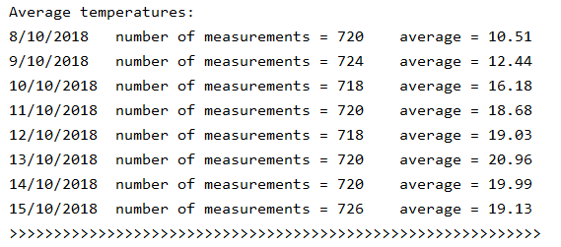

**Exercise 4**

In this exercise you use the file *sponsors.txt.* This file contains not only the unique number of the sponsor, but also his first name and surname and the sponsored amount.

These amounts were sponsored to a charity and some sponsors regularly make a donation.

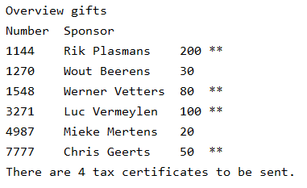Write a program that prints this overview. For each sponsor it is stated how much he/she deposited in total.

** indicates that the sponsor will receive a tax certificate.

A sponsor receives a tax certificate in Belgium if his total amount paid is at least 40€.